Small Business DCO
Business Profile pages

Decision document

Ian Hicks
Digital Program, DCO Stream
September 21, 2020

Introduction
This document is to finalize content and UI/UX treatment requirements for 2 pages fundamental to the Small Business DCO process, related to gathering of detailed business profile information.
- Your Business – basic business profile information
- More About Your Business – extended business profile information (type/size, industry and registration-related fields)
Team feedback gathered upon initial review and decisions requested are called out with each page detailed below.

Organization / distribution of data across pages
From initial reviews held Sep 9 & 11, the team agreed with this logical breakdown of data across pages:

Your Business page

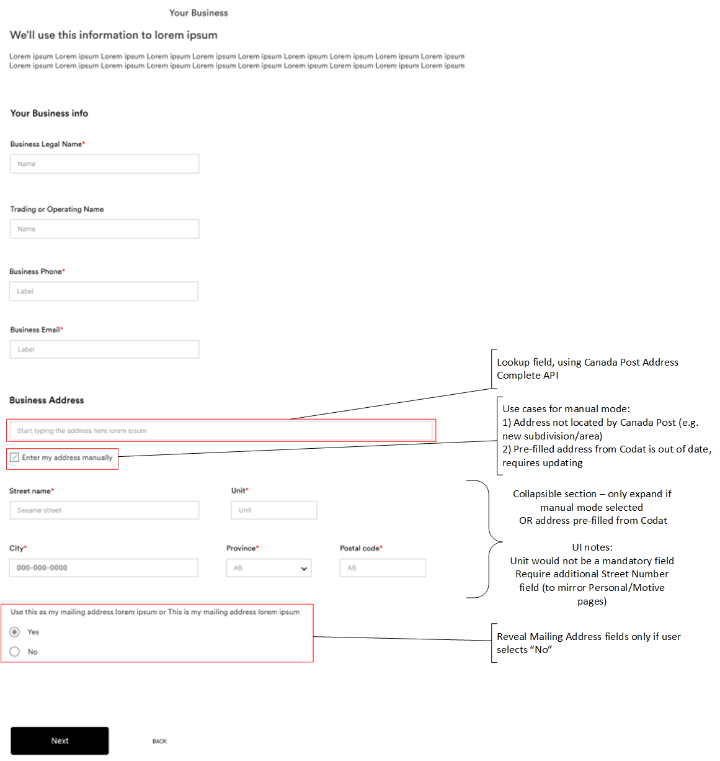
Team notes and recommendations
Business Phone and Business Email are sufficient for contact fields.
Phone/Email for applicant and other individuals are captured elsewhere.
Capture Business (Legal/Registered) address first, before (optional) Mailing Address.
If technically feasible, only reveal individual address components if using “manual mode”
As noted, Use Cases for manual mode are (1) address not found by Canada Post service and (2) address is pre-filled via Codat integration (and may need to be updated).
If technically feasible, disable/disallow entry in Canada Post lookup field when using manual mode.
Reveal Mailing Address fields only if user indicates the business has a different Mailing Address.

Decision 1 requested
Approval for development with fields and behaviours as noted.
Initial wording/labels/captions as in following extract from Field Specification, subject to review by Connie S.

Your Business - Field Specification (interim labels/captions)

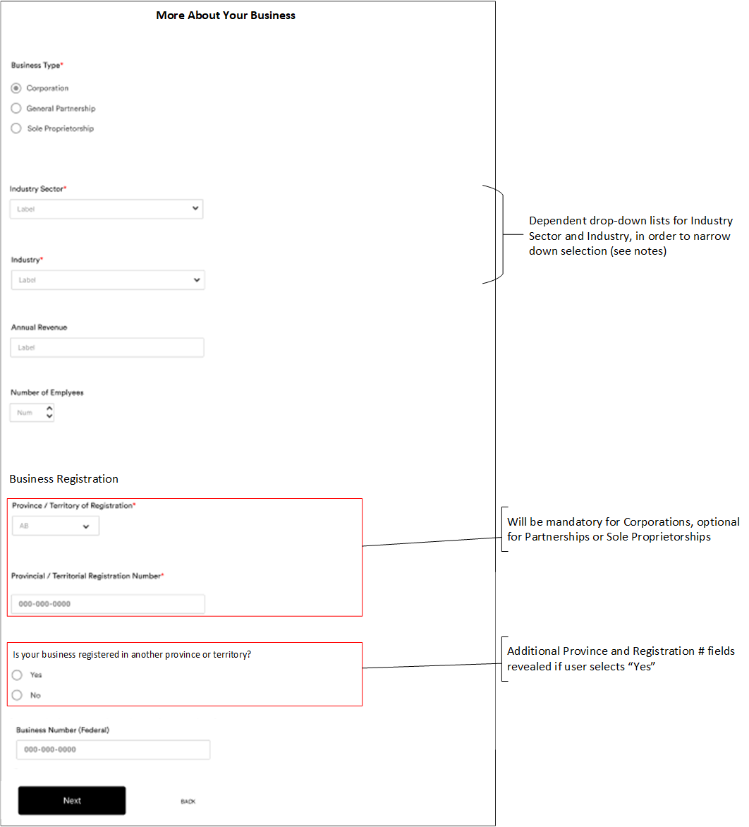
More About Your Business page

Team notes and recommendations
- See next section for options.
Industry (NAICS) lookup via two dependent drop-downs is probably a good compromise between usability and functionality. This will also make the design similar to the revised occupation (NOC) lookup on the personal side.
  - Temenos have built this function using a single type-ahead field (similar to the Canada Post address service), however there are ~900 NAICS descriptions and they are not always intuitive. This is exacerbated somewhat by CWB using an older (2007) version of NAICS at present (due to reporting dependencies).
  - The Thirdstream approach built for Coast Capital used a 3-level lookup (Sector, Subsector and Industry). There may be some merit to using Subsectors in some cases.
- Annual Revenue (new field, being added for DCO) will be an optional data entry field in which the user will enter an amount. Zero would be a valid value (e.g. a new business with no revenue as yet).
- Number of Employees (new field, being added for DCO) will be an optional field and zero will be a valid value. We can set a limit on the highest number allowed by using this treatment.
- Provincial/territorial registration is placed first in the registration section, as it is required for the Business Search API (and will be mandatory in the UI for Corporations).
  - This field can be optional for Partnerships or Sole Proprietorships, as these do not need to be registered. In these cases (expected to be infrequent), the Business Search API would not be invoked and the application would need to be flagged for manual review. This will allow follow-up by a CWB staff member to obtain required verification documents.
- The team felt that the ability to add one other provincial/territorial registration (i.e. extra-provincial registration) is adequate for our purposes (a third or subsequent registration would be an edge case).

Decision 2 requested
Approval for development with fields and behaviours as noted.
Initial wording/labels/captions as in following extract from Field Specification, subject to review by Connie S.

More About Your Business – Field Specification (interim captions/labels)

Industry / NAICS lookup options
- Single type-ahead lookup field, similar to Canada Post Address Complete.
  - Not recommended due to number of NAICS descriptions (~900), which are not all intuitive. Would likely lead to user frustration as evidenced by the occupation (NOC) lookup built for Motive.
- Two dependent drop-down lists (Sector and Industry) – as illustrated in previous page.
  - There are only 20 values for Sector. Mandating selection of Sector will allow the second list (Industry) to be filtered down to a reasonable number of choices
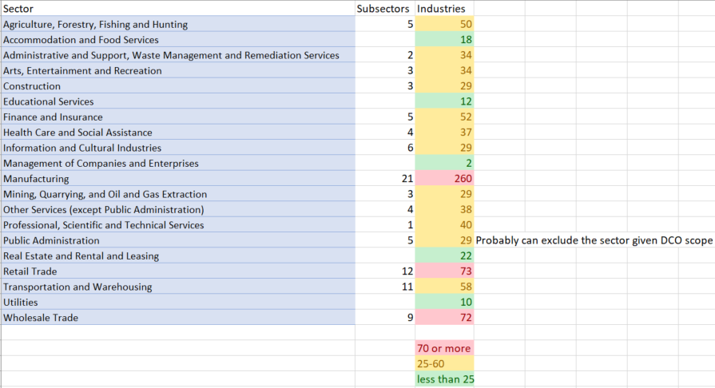
    - Further analysis reveals a wide variation in the number of Industry codes associated with each Sector: for some of the longer lists (highlighted red and yellow below), it may be prudent to use Subsector instead, which would make the Sector list (if it was a blend of Sector and Subsector values) longer, but still achieve the aim of making the Industry selection easier.
    - Integration note: regardless of UI solution, Sector needs to be derived anyway and passed to T24 when creating a non-personal CIF.
  - There are definitely some Industries, and possibly some Sectors/Subsectors, that would never be utilized by clients onboarding via Small Business DCO. As such, it would likely be worthwhile to undertake some rationalization to reduce the lists made available in the DCO UI, in order to improve usability.

- Three dependent drop-down lists (Sector, Subsector and Industry).
  - Potentially makes filtering to find the correct industry easier, but adds to the burden on the user, in terms of “clicks” to complete. Similarly to the relationship between Sector and Industry, there is also wide variation in the number of Subsector values per Sector and Industries per Subsector.
  - This three-level approach has been implemented by Thirdstream, in the onboarding product built for Coast Capital.

Decision 3 requested
Approval on preferred NAICS lookup mechanism.
Team recommendation was #2 above: suggest augmenting this approach by using a “blended” list of Sector and Subsector, plus rationalizing the lists at all levels to reduce the number of selections made available in the DCO UI.

Handling of prohibited and restricted industries
CWB has a small list of industries considered “prohibited” and “restricted”.
- Any business operating in a prohibited industry cannot open an account.
- A business operating in a restricted industry may be accepted and onboarded, subject to review and approval by CWB regulatory teams.
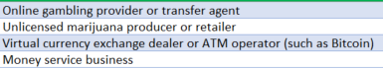
Prohibited
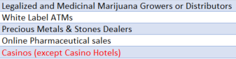
Restricted

In terms of the NAICS industry classifications, ONLY “Casinos” matches one of these prohibited or restricted definitions.
- Temenos can add flags to their NAICS lookup list to identify prohibited and/or restricted industries, however because there is no direct match to most of the list specified by CWB, we would need to guess the most likely value to be selected by someone attempting to onboard a business in one of these industries.

Options
- Add descriptions for the prohibited and/or restricted industries to the available lookup list, so allowing for their selection. Have Temenos implement flags to identify them as prohibited or restricted. Doing so would then lead to the application being flagged for manual review. No validation or error messages would be presented to the client in the UI. On the back end, we are not creating a CIF until later in the process, but in the event that such a client is accepted, we would need to have someone select/set an appropriate NAICS value for them before the CIF can be created.
  - Note: in this case we would essentially not make a distinction in the UI between prohibited and restricted, as all cases would be flagged for manual review (via Workspaces). To reduce the chances of a hard decline later (or letting through businesses that should be declined or at least reviewed), we could omit the prohibited industry descriptions from the lookup, but add the restricted flag on “close” candidate industries that we may want to review manually, as a risk mitigation exercise.
- Add descriptions for the prohibited and restricted industries to the available lookup list, so allowing for their selection. Have Temenos implement flags to identify them as prohibited or restricted, in conjunction with some kind of validation in the UI.
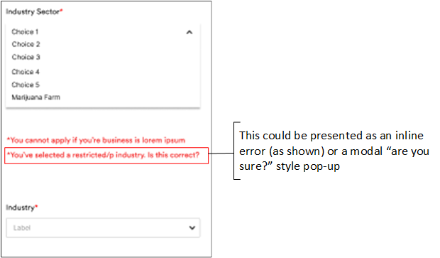
  - The drawback of this approach is that it would likely change the behaviour of some applicants. A hard stop “you cannot continue” message (for prohibited industries) might cause the applicant to select a different value, if they have made it this far and are determined to continue with the application, or may just cause them to abandon.
  - An “are you sure” type message for a restricted industry may have similar results, although that theory would need to be tested. The propensity to change selection or abandon may depend on the language (if we are suggesting their application is treated differently, because of the industry they selected).
- Do not add the CWB-defined prohibited and restricted industries to the DCO lookup. Have Temenos implement a flag to identify restricted industries. Initially, this can be set for Casinos. It may also be prudent to set this flag for any industry descriptions that are “close” to something CWB considers prohibited/restricted, to ensure these applications would be reviewed by a person. As with the other options, any such applications would be flagged for manual review.
  - Examples: CWB considers Precious Metals & Stones Dealers and Online Pharmaceutical Sales as restricted: someone in such an industry may select one of these NAICS descriptions, so these could all be flagged as restricted in the lookup list
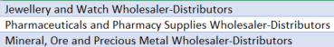

Decision 4 requested
Approval on preferred handling for prohibited and restricted industries.
There is no team recommendation, as we did not have the opportunity to fully develop all of the above scenarios. In terms of client experience, #1 would likely provide the most seamless workflow. Leaving CWB-defined prohibited industries out of the selection list, together with careful application of the restricted flag, would serve to manage the volume of manual reviews required and mitigate some of the risk associated with businesses in “marginal” industries applying (and being accepted) online.

